Payroll System

System Architecture Document

Thanh Pham | Muhammad Qamar

Business Systems Analysis & Design  
ISOM 4163  
Professor Cheng

Submission Date: April 1, 2023

Software Architecture Document

# Introduction

This system is designed to streamline the payroll process, increase accuracy and efficiency, and provide employees with an easy-to-use platform for managing their finances. The Payroll System will feature biometric scanners for clock-in and out, automated tax calculation, and a variety of saving functions. This new system will be a comprehensive solution for the entire organization, providing users with a friendly and reliable platform to track their finances and communicate important information to their managers and HR department.

## Purpose

The purpose of the System Architecture Document is to provide a comprehensive overview of the Payroll System for a Technology Company. This document will capture the significant architectural decisions made during the development of the system, including the selection of software and hardware components, as well as the overall system design. This system is designed to automate and manage employee compensation calculations and distribution, ensuring accuracy and timeliness of payment while processing the tax process. Besides, the system will include other documents for decision making, tax and financial statements. Moreover, this new Payroll System will include a saving money function, allowing employees to save a portion of their paycheck into designated savings accounts. By providing a comprehensive system of Payroll will help stakeholders and even employees easy to enable analyze information also gaining deeper understanding of company workflow via system.

**1.2 Overview**

The purpose of the Payroll System for a Technology Company is to automate and manage employee compensation calculations and distribution. The system will ensure accuracy and compliance with relevant tax laws and regulations, while providing valuable financial information for decision-making and necessary documents for tax and financial statements.

Some of the other important features:

Money-saving feature:

* + Saving a portion of their paycheck into designated saving accounts (generated by company policies).
  + Supporting employee satisfaction and financial management within the organization. (Enhance them to support this feature for helping company cash flow also ensure raising benefit of employees)

Tracking employee attendance for paycheck:

* Calculate wages based on employees’ attendances and work hours.
* Tracking employees’ working rate to determine bonus and other compensation elements.
* Contain dashboard of employee’s working hour, distribute paychecks (including information such as financial documents, statements, etc.)

Tax Calculation and Information:

* Generate Tax forms: W-2 and 1099 forms.
* Year-end tax total documents, including other financial statements.
* Other documents such as compensation reports, labor cost analysis (for head of department estimate personnel salaries and nonfinancial benefits) and financial data.
* Overall, these are some of significant features of the New Payroll System that will deliver a comprehensive solution for organization in controlling company processes such as accuracy rate, compliance and optimal employee experience.

Figure 1. System Overview

# Architect detail

2.1 Data movement/Data Flow Diagram (Refer to the textbook for the notation conventions)

# Menu & Functional Menu Items

The following is the high-level view of user case view to show the pages the end user will be able to access.

*Images are only proof of concept and are subject to change*

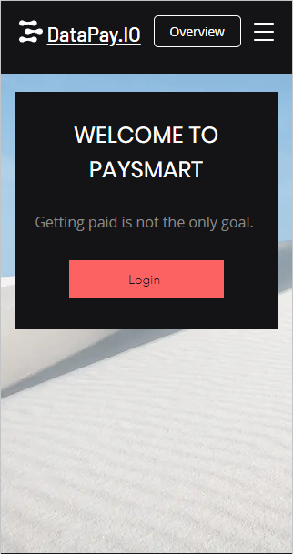

# 3.1 System Function # 1 - Login

The Login menu will determine the constraints and access of the end user logging in. The Fabric Employee will open the application on an iPad and then log in with their required credentials.

Once an employee enters credentials for the Login screen/form, they will be directed to the **Services menu screen.**

*Images are only proof of concept and are subject to change*

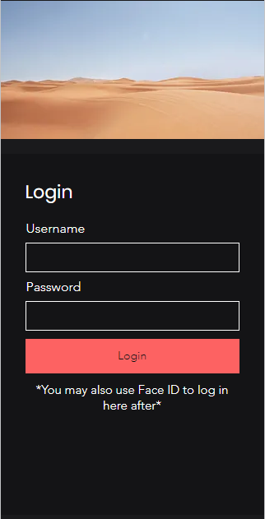 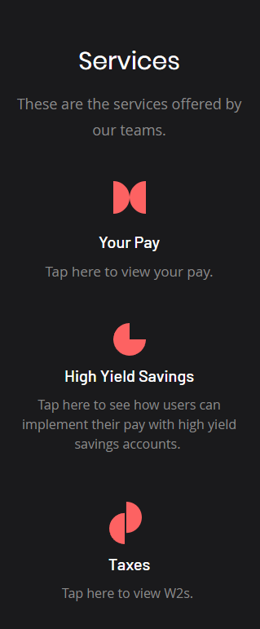

# 3.2 Screen/Form of Sub Menu Item#1

# By clicking on the “Your Pay” tab, end users can see a summary of their pay as shown below.

# This summary includes their hours worked, overtime hours, the pay rate, what taxes and deductions were taken, and how their money was distributed. This can change depending on what different features the user may want such as attendance, clock in/out times and even their year-to-date summaries.

*Images are only proof of concept and are subject to change*

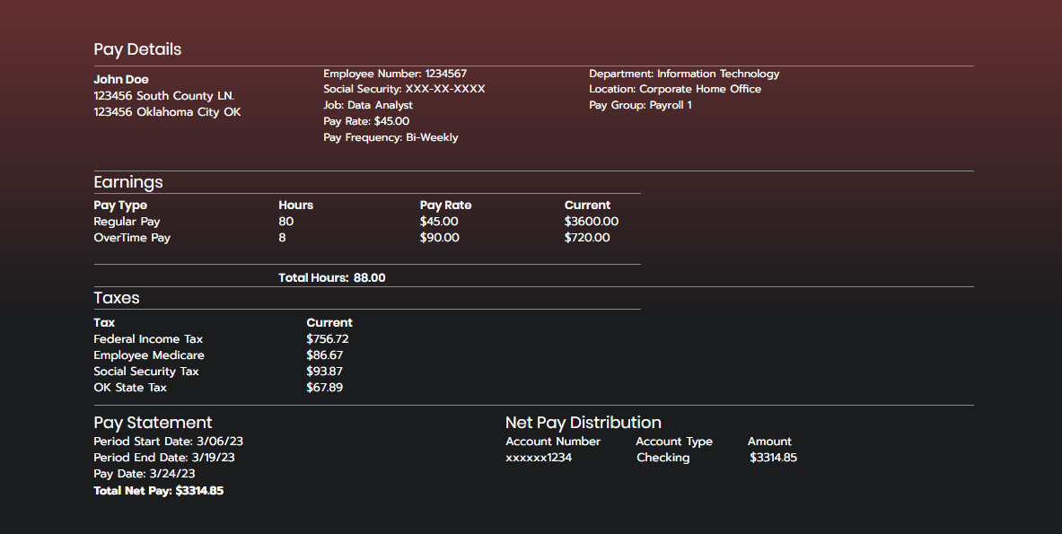

# 3.3 Screen/Form of Sub Menu Item#2

When users select the “High Yield Savings” service they will then be brought to this page which shows them an account summary of their high yield savings account. If a user does not have a high yield savings account this page will show “No account found” and direct them to the more savings tab which gives users, the information needed to start a high yield savings account and things to look for.

*Images are only proof of concept and are subject to change*

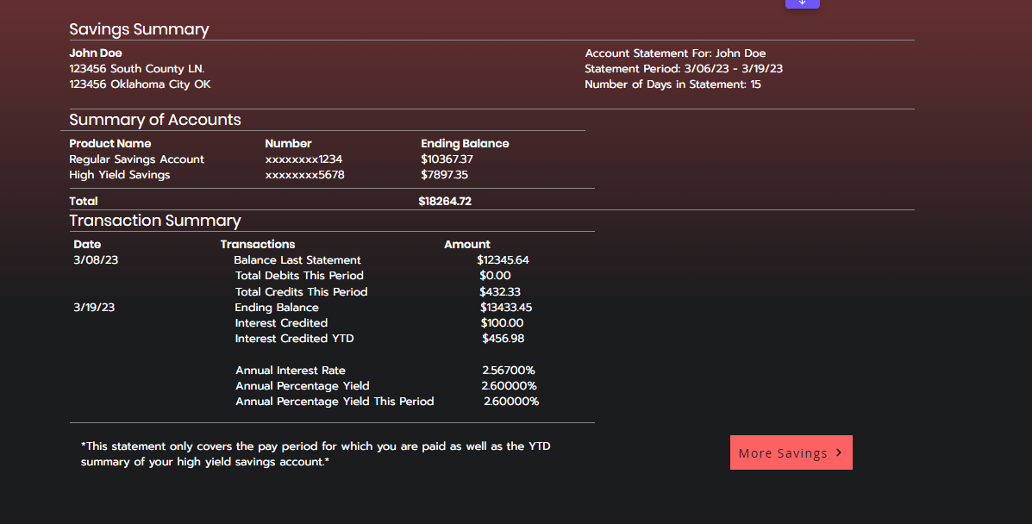

# Data View

The data view of PaySmart Payroll is an essential part of the architecture plan as normalization enforces consistency and quality through primary key and foreign key constraints.

# Technology

The PaySmart Payroll System will use the following technologies:

* Database System such as Oracle, OnBase, Azure Database
* Face ID or Touch ID
* Apple/Android OS
* Database Servers

# Supporting Documents (Mention your Project plan, SRD, etc).

**6.1 Project Plan**

Having a Project Plan helps our team to manage the progress, then you can base on it to allocate and coordinate human resources for the project. Thereby, you can create a budget esitmation to control financial of the project. Afterwards, establish a basis for determining time, cost and quality requirements. Hence, helps avoid or mitigate risks to generate a well-crafted for Project Plan for the SAP to deliver project on time and fit budget.

**6.2 SRD (System Requirement Document)**

The System Requirement Document (SRD) is an outline of a project that includes functional and non-functional requirements for a software project. The features of the application are described in detail to provide insight into how the software will work. Scenarios for setting up the software are defined and additional features to be added are analyzed. Finally, the document shows the process of the software to see how it is running.

**6.3 Assessment of two supported documents above:**

These documents provide a solid foundation for the SAP proposal, helping to ensure that the proposed solution aligns with the client's requirements and the project can be completed on time and within budget.